Unit 14 – Intermolecular Forces
(Section 10.4)

I Can Statements:

1. I can explain the difference between intermolecular forces and intramolecular bonds
2. I can explain the term Van der Waals Forces
3. I can list and explain the nature/strength of all the Van der Waals forces:
a. London Dispersion
b. Dipole-Induced Dipole
c. Dipole-Dipole
d. Hydrogen-Bonding
e. Ion-dipole
4. I can determine the type of Intermolecular Force between any two given particles.
a. the composition of a substance and the shape and polarity of a molecule are important in determining
the type and strength of bonding and intermolecular interactions.
5. I can explain the role of intermolecular forces on each of the following:
a. melting and boiling points of substances
b. solubility of substances
c. properties of water (e.g. surface tension, ice expands, high heat capacity, etc.)

Vocabulary:
Dipole
Dipole-Dipole
Dipole-Induced Dipole
Hydrogen Bonding
Induced Dipole
Ion-Dipole
Intermolecular Force
London Dispersion Force
Van der Waals Force

Achievement Scale:
Goal | C Level | B Level | A Level
10.4  IMFs | - Can explain the term Van der Waals Forces  - Can list and explain the nature of all the Van Der Waals Forces  - Can explain the role of intermolecular forces on melting and boiling points, surface tension, viscosity, DNA, and water | - Can determine the type of intermolecular force between any two particles

Sample Question:

1. Answer the following questions based on the Lewis Structure for water shown below:
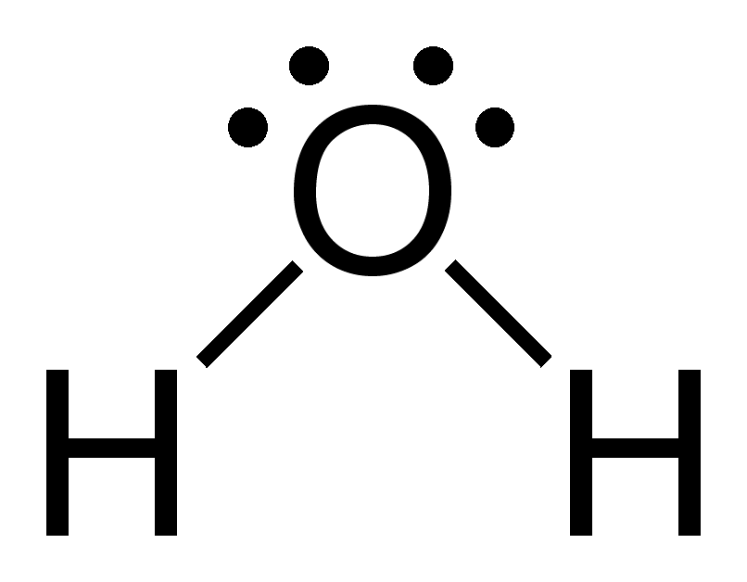
(a) Draw the bond dipoles on this molecule.
(b) Is the molecule polar? Explain. YES, the direction of the bond dipoles is “additive”
(c) What type of van der Waal force exists between two water molecules? Hydrogen - bonding
(d) Explain how intermolecular forces contribute to water’s high boiling point?

2. Determine the type of forces that exists between the following pairs of molecules:
a. HF and HF Hydrogen Bond
b. HCN and CH₄ Dipole-Induced Dipole
c. CO₂ and O₂ Dispersion Forces
d. NaCl and H₂O Ion-Dipole
e. HBr and NH₃ Dipole-Dipole

